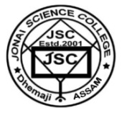
OFFICE OF THE PRINCIPAL JONAI SCIENCE COLLEGE
Udoipur, P.O.Jonai, Dist: Dhemaji Assam, PIN-787060

Dr. Rajeswar Pegu M.Sc,Ph.D. Ph.No: 9954822736 . Principal
Ref. No:JSC/ ___________________________ Dated: Jonai the 3OTH June, 2023

NOTICE
It is notify that, summer vacation of HS and semester break of UG course will be start from 1st July, 2023 and will be end on 31st July, 2023 for 31 days. The classes will be re-starting from 1st August, 2023 including HS first year and 1st semester of FYUGC.

Principal Jonai Science College.

